Name: K. Guna Shekar Reddy
Register Number: 192424323
Course Code: CSA0918
Course: PROGRAMMING IN JAVA
CO1-AT3-FLOWGORITHM FLOWCHART
Question 1:
Read the number of correct, wrong, and unanswered questions. Calculate a score using +4 for correct, -1 for wrong, and 0 for unanswered.
Flow Chart:
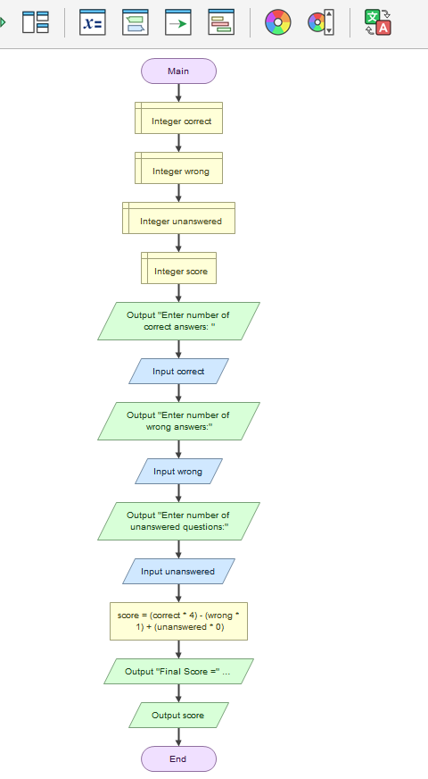
Output
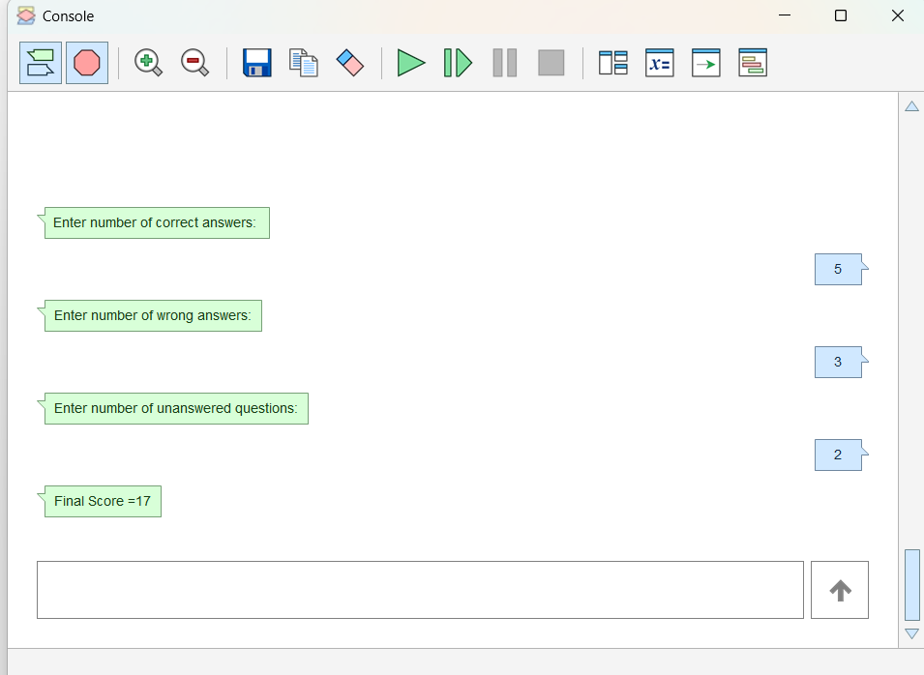
Pseudo Code
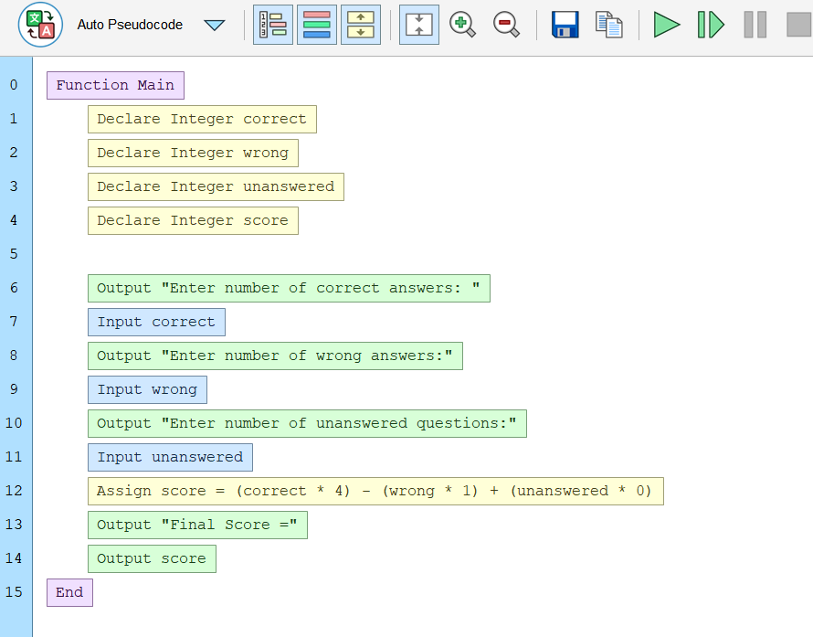
Java Code
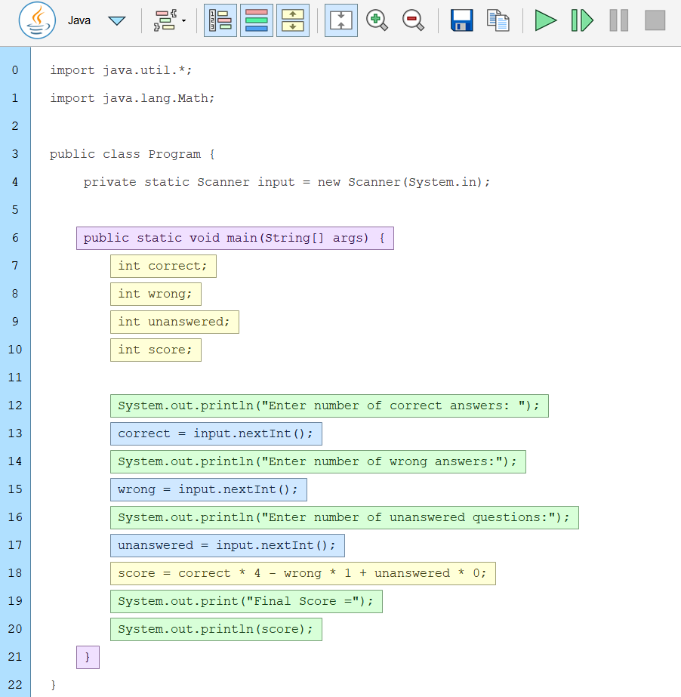

Question 2:
Read a positive integer and find the sum of all prime numbers up to that integer.
Flow Chart:
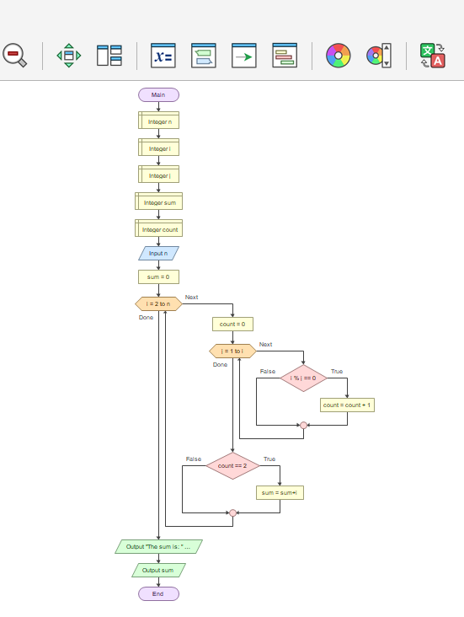

Output
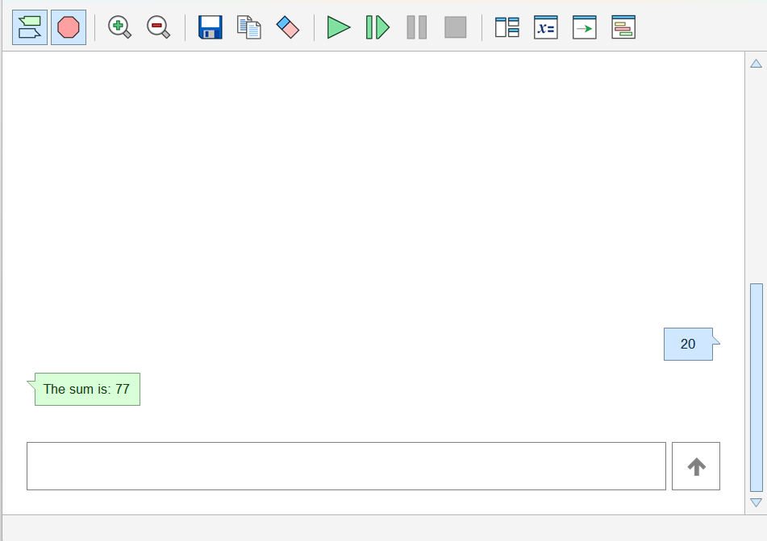
Pseudo Code
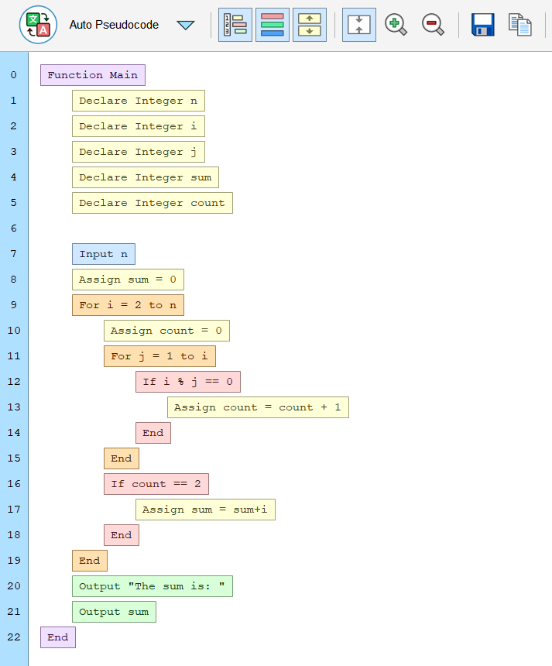
Java Code
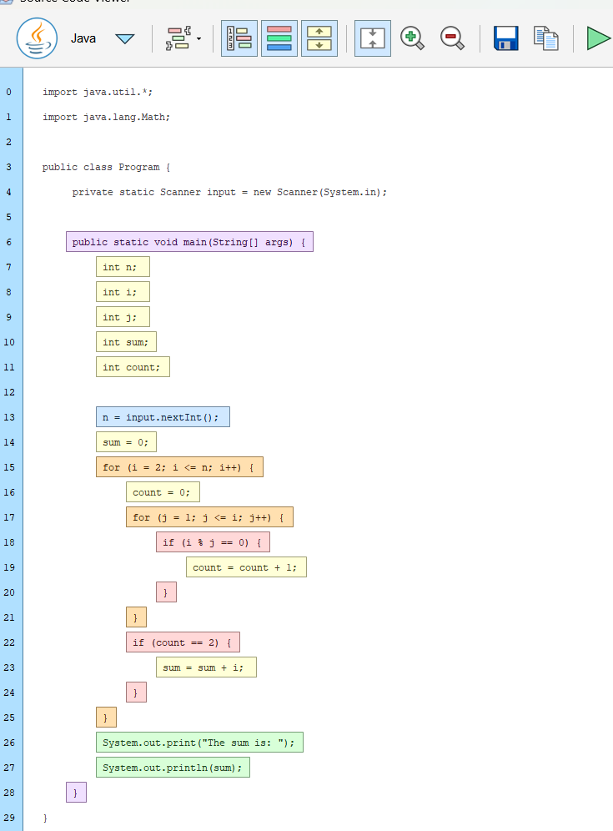

Question 3:
Create functions for deposit and withdrawal that return the updated balance. Process a sequence of transactions selected through a menu.
Flow Chart:
Main
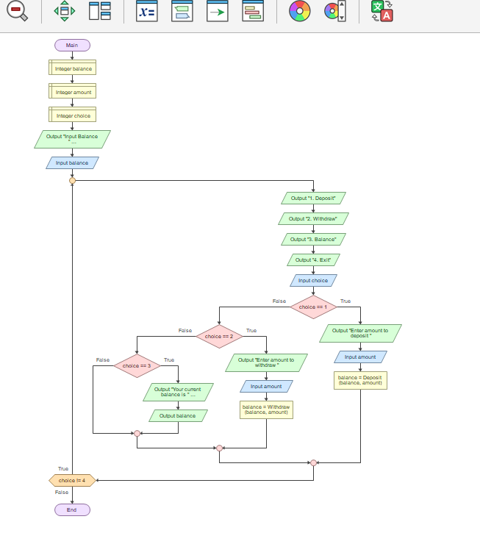

Function Deposit
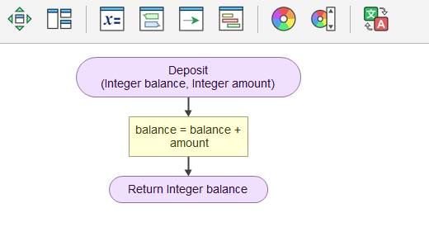
Function Withdraw

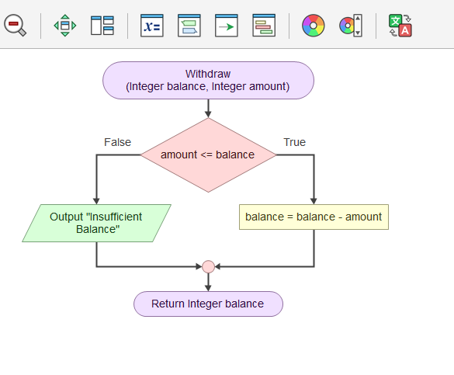

Output
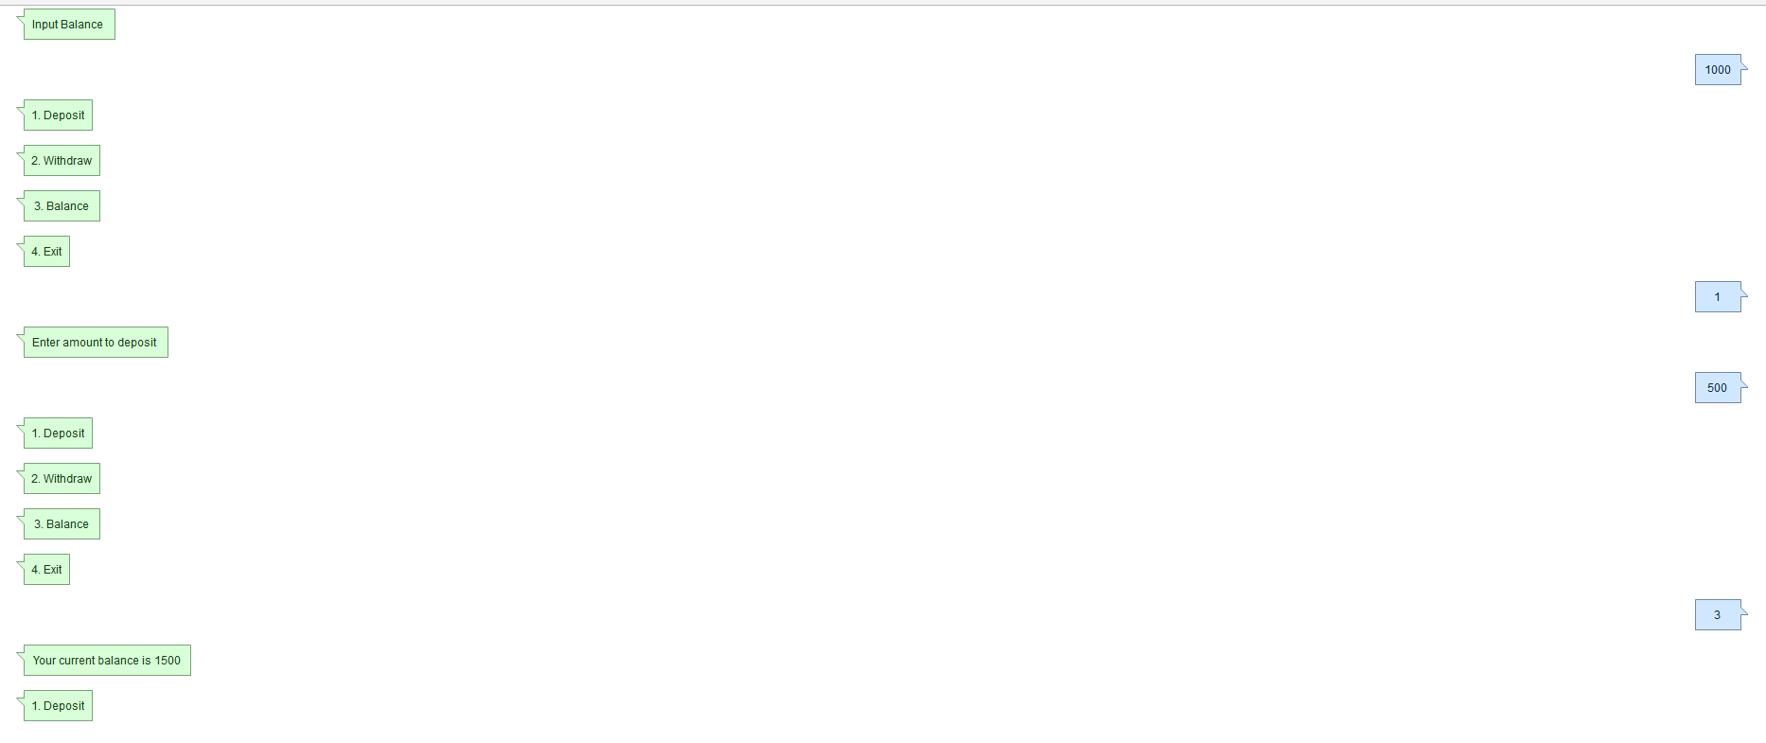
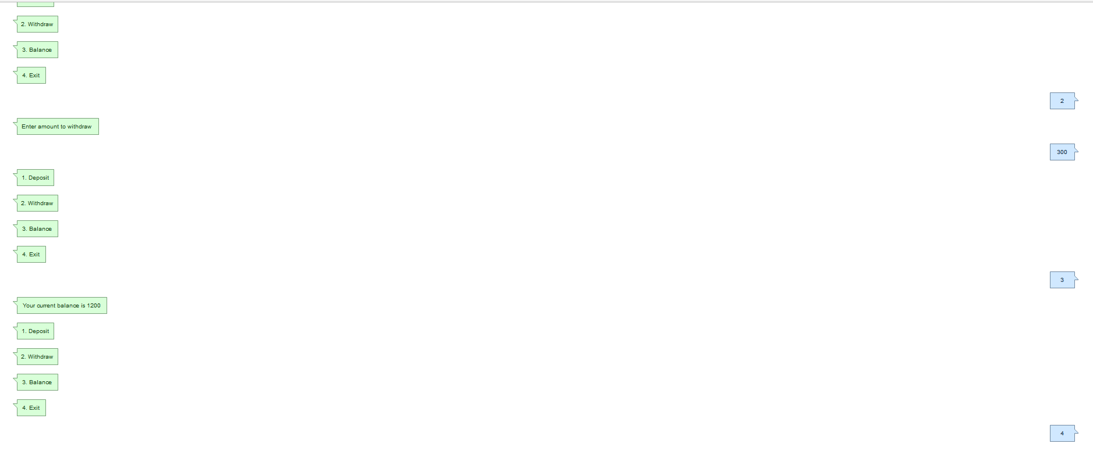

Pseudo Code
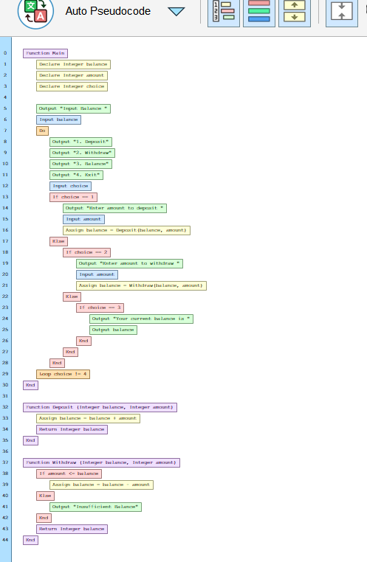

Java Code
